

Read and understand the following text and warnings before attempting installation.
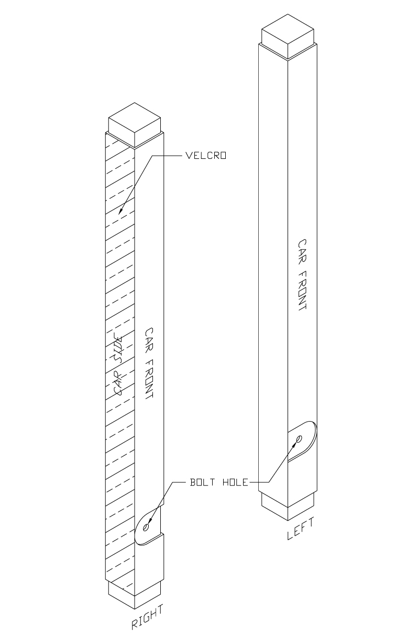
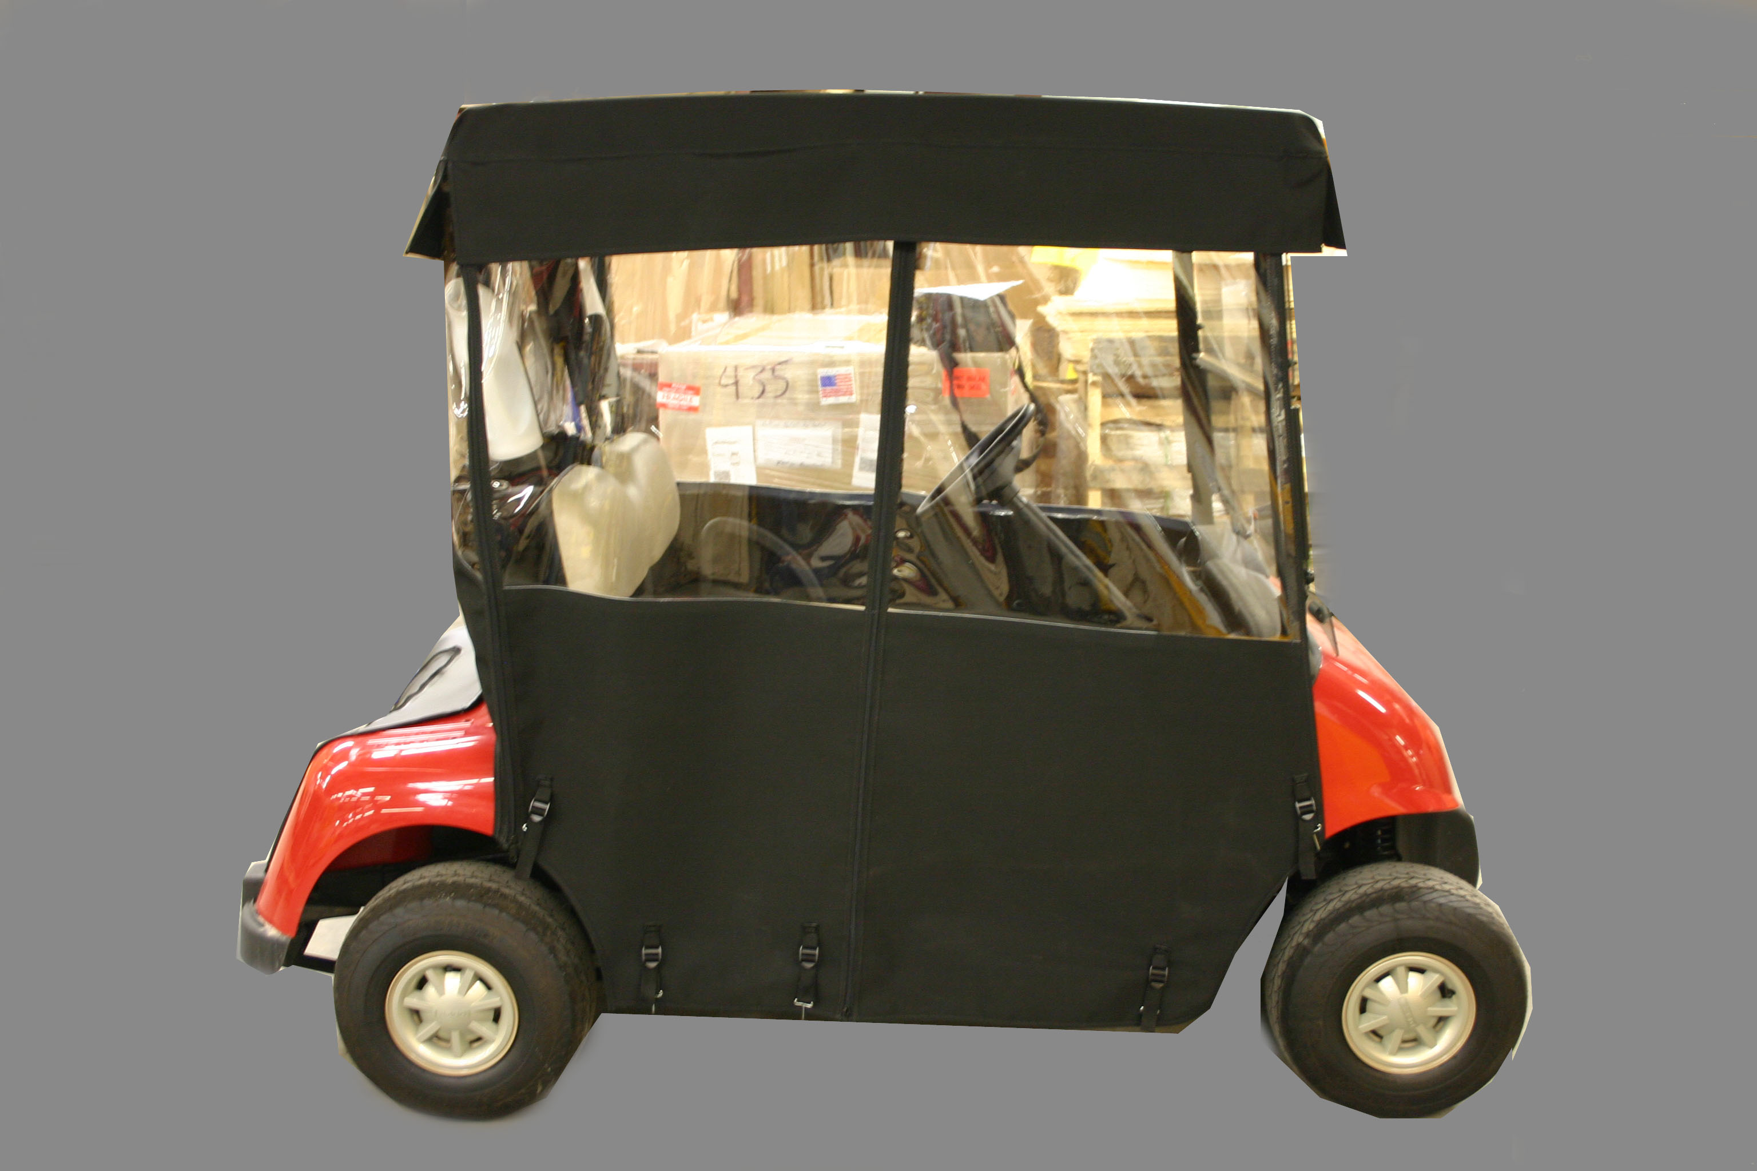
Place enclosure over the car top; open end with Velcro on the inside edges to face forward.

Rear panel should fall inside rear uprights and then zip to side panels.
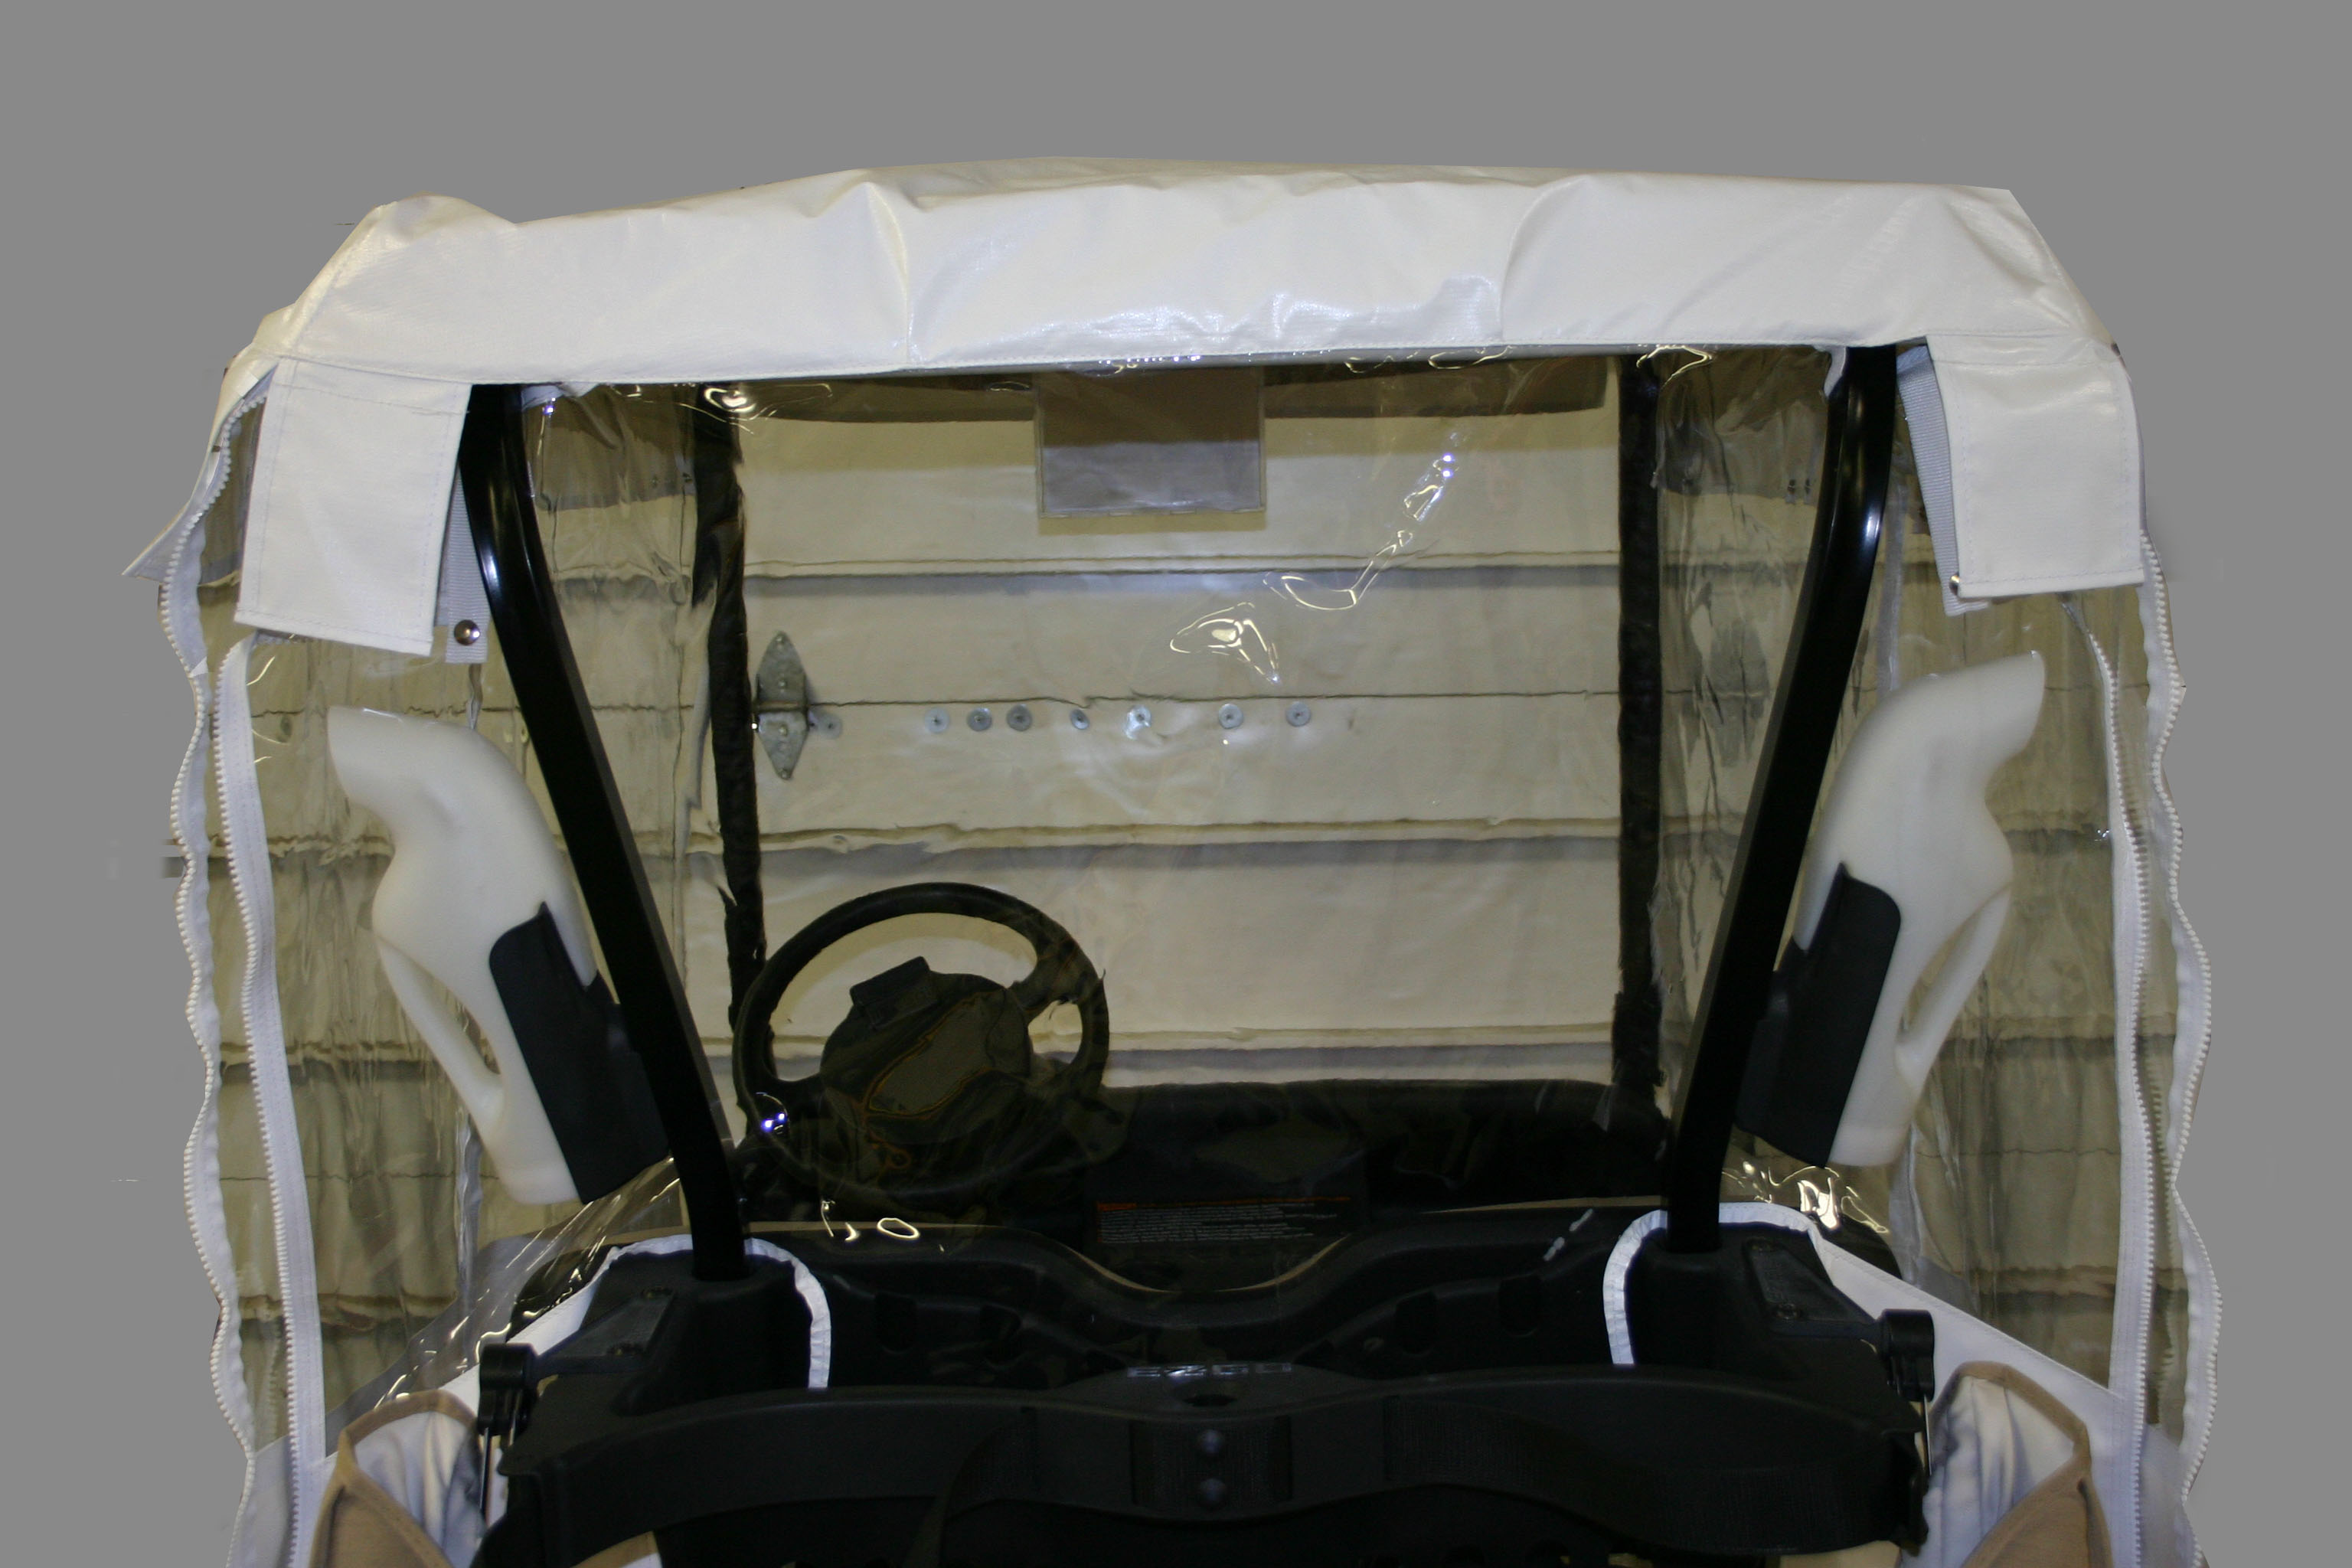
Position roof support wrap as shown; 2” Velcro to show on outside of metal roof support
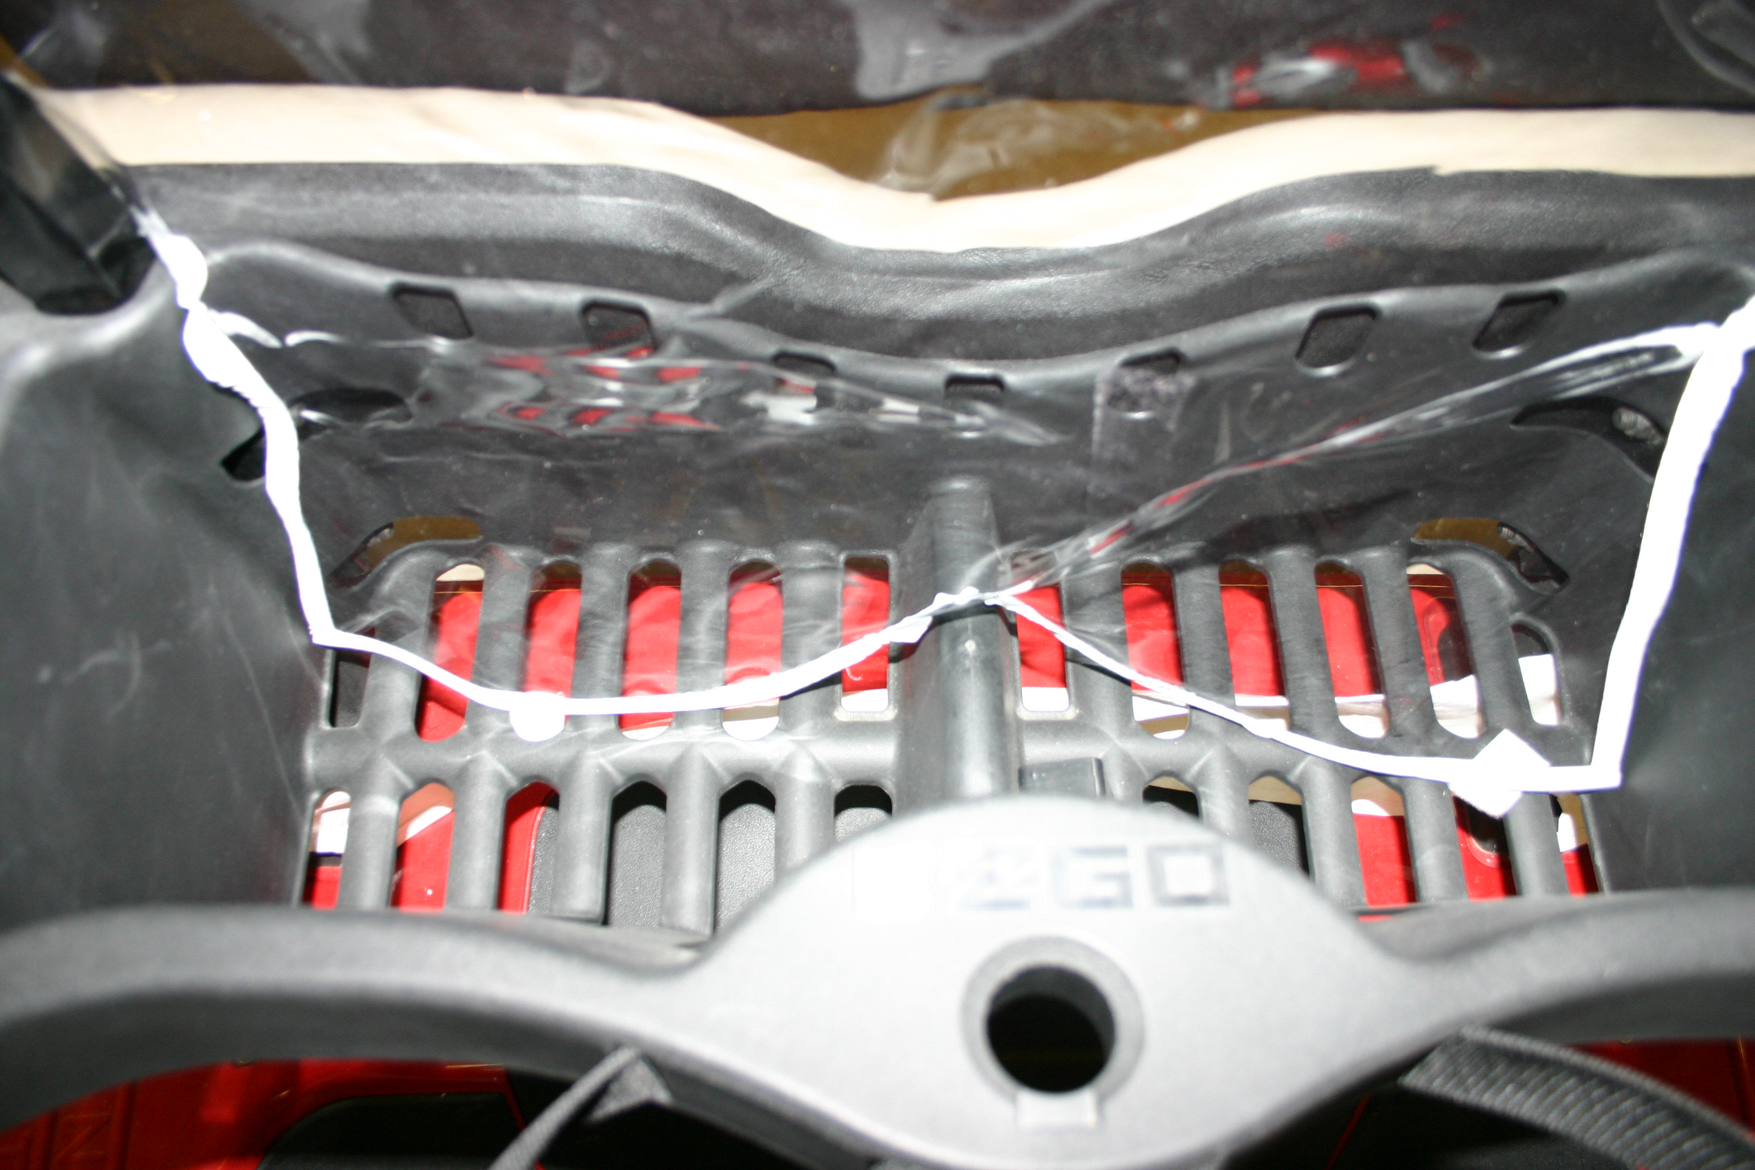
Allow rear flap to lie in rear basket. Feed Velcro tabs through basket and attach to bottom strip underneath basket.
Package Contains
(1) Left front roof support wrap
(1) Right front roof support wrap
(2) Adhesive Velcro strips
(1) Enclosure with roof, 2 sides, rear

Step 1: Remove windshield

Step 2: Remove extruded vinyl windshield retainer clips

Step 3: Attach left and right upright wraps so that Velcro is on the outside of uprights and the wrap cutouts are located so that window bolts can be reinstalled

Step 4: Remove upper attachments of rear bag cover and allow it to hinge down onto basket

Step 5: Place enclosure on car (over top)—connect underside Velcro straps diagonally on rear roof corners.

Step 6: Unzip rear panel from sides and insert behind rear uprights. Zip back to side panels.

Step 7: Allow rear flap to fall behind seat and inside basket. Attach Velcro tabs through basket to bottom strip.

Step 8: Reattach bag cover

Step 9: Reinstall windshield adding adhesive Velcro to retaining clips providing continuous Velcro face on uprights

Step 10: Attach and smooth front of enclosure to the continuous Velcro face on uprights

Step 11: Engage retaining hooks along bottom edge of enclosure—pull tight

